**Practical No. 01**

**TITLE:** BLUETOOTH FILE SHARING

**AIM:** TO STUDY BLUETOOTH FILE SHARING

**APPARATUS:** MOBILE DEVICES

**THEORY:**

**Introduction to Bluetooth:**

Bluetooth is a Wireless Personal Area Network (WPAN) technology and is used for exchanging data over smaller distances. This technology was invented by Ericson in 1994. It operates in the unlicensed, industrial, scientific and medical (ISM) band from 2.4 GHz to 2.485 GHz. Maximum devices that can be connected at the same time are 7. Bluetooth ranges up to 10 meters. It provides data rates up to 1 Mbps or 3 Mbps depending upon the version. The spreading technique that it uses is FHSS (Frequency-hopping spread spectrum). Bluetooth wireless technology is a short range communications technology intended to replace the cables connecting portable units and maintaining high levels of security. Bluetooth technology is based on Ad-hoc technology also known as Ad-hoc Pico nets, which is a local area network with a very limited coverage. A Bluetooth network is called a piconet and a collection of interconnected piconets is called scatternet.

Bluetooth Transmission capacity 720 kbps. Bluetooth is Wireless. Bluetooth is Low cost short distance radio communications standard. Bluetooth is robust and flexible. Bluetooth is cable replacement technology that can be used to connect almost any device to any other device. The basic architecture unit of a bluetooth is a piconet.

Bluetooth specification details the entire protocol stack. Bluetooth employs Radio Frequency (RF) for communication. It makes use of frequency modulation to generate radio waves in the ISM band.

Features of Bluetooth -

1. Bluetooth offers a uniform structure for a wide range of devices to connect and communicate with each other.
2. Bluetooth technology has achieved global acceptance such that any Bluetooth enabled device, almost everywhere in the world, can be connected with Bluetooth enabled devices.
3. Low power consumption of Bluetooth technology and an offered range of up to ten meters has paved the way for several usage models.
4. Bluetooth offers interactive conferences by establishing an adhoc network of laptops.
5. Bluetooth usage model includes cordless computer, intercom, cordless phone and mobile phones.

**Bluetooth File Transfer:**

Without the use of an additional app, Bluetooth file transfer is an easy way to send files to another nearby Bluetooth device. Smartphones, tablets, laptops, and desktop computers all support Bluetooth. Android OS, Fire OS, Windows OS, Mac OS, and Linux OS support Bluetooth file transfers.

iOS and Chrome OS do not support Bluetooth file transfer. In order to transfer files and photographs from an iOS device to an Android or Chrome OS device over Bluetooth, you must use a different programme, such as Move to iOS or Apple AirDrop. A system setting called Bluetooth Share supports Bluetooth and is available on devices that can transmit files over Bluetooth (or something similar).

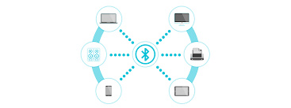

The limitation of using Bluetooth to transfer data is the size of the files versus the transfer rate. The Bluetooth transfer rate depends on the version:

1. Bluetooth 2.x has a maximum data transfer rate of 2.1 Mbit/s (about 0.25 MB/s).
2. Bluetooth 3.x has a maximum data transfer rate of 24 Mbit/s (about 3 MB/s).
3. Bluetooth 4.x has a maximum data transfer rate of 24 Mbit/s (about 3 MB/s).
4. Bluetooth 5.x has a maximum data transfer rate of 50 Mbit/s (about 6 MB/s).

Steps for Bluetooth Transfer:

1. Pairing via Settings -
2. Go to Settings > Bluetooth  and switch to activate bluetooth.
3. Device will scan for nearby devices. Tap on which device you want to pair with.
4. Verify that the pin is the same on both devices and then tap OK.
5. The devices are paired. To unpair, select Settings beside the Paired device and tap Unpair.
6. Transfer files via Bluetooth -
7. Open the folder to find the files to be transferred.
8. Select the file to be shared and select the share option on the screen.
9. Select Bluetooth in the share panel.
10. The Bluetooth menu will open and scan for available devices. Select the device to receive the files.
11. Select Accept on the receiving device.

**User Scenario:**

1. Open the folder to find the files to be transferred.

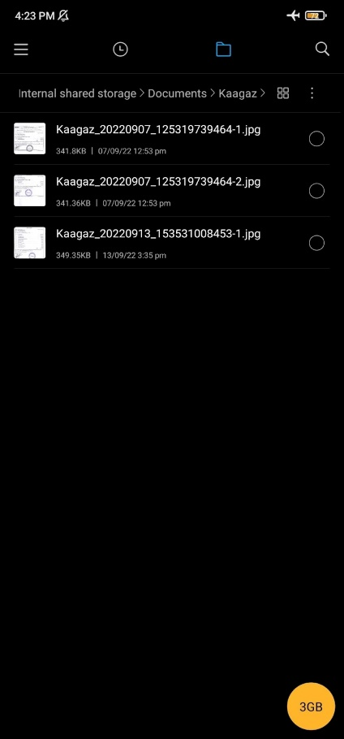

1. Select the file to be shared and select the share option on the screen.

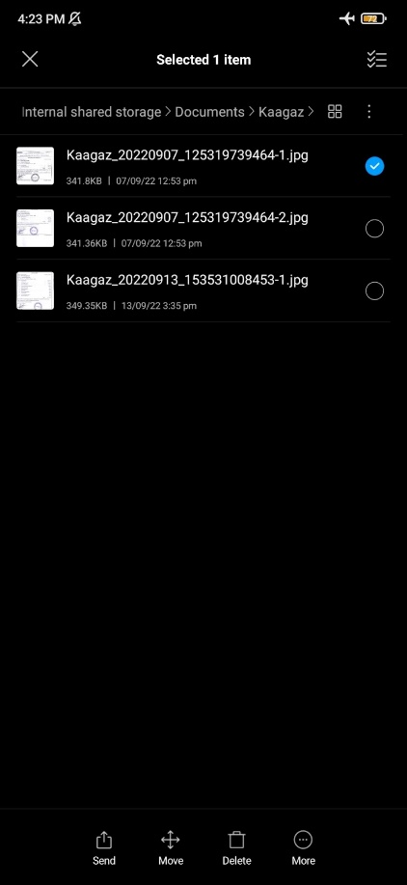

1. Select Bluetooth in the share panel.

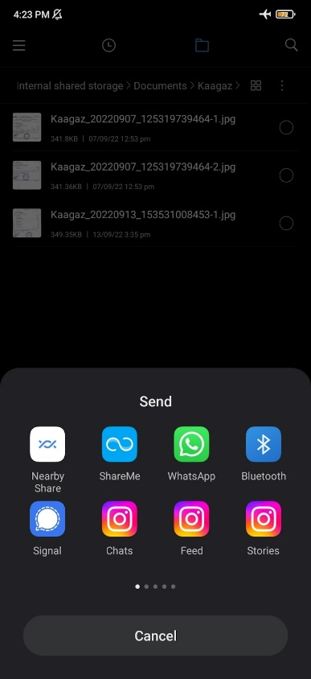

1. The Bluetooth menu will open and scan for available devices. Select the device to receive the files.

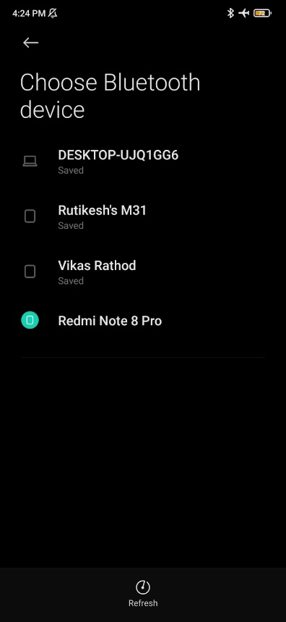

1. Select Accept on the receiving device.

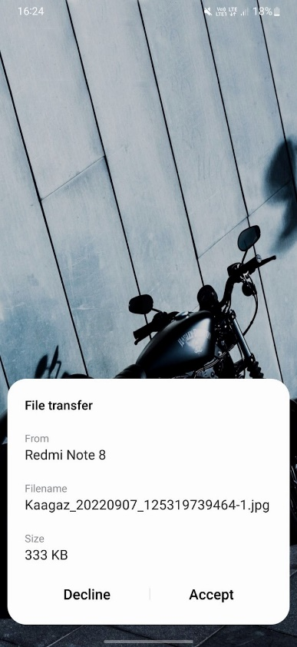

**Bluetooth Architecture:**

The architecture of Bluetooth defines two types of networks:

1. Piconet

2. Scatternet

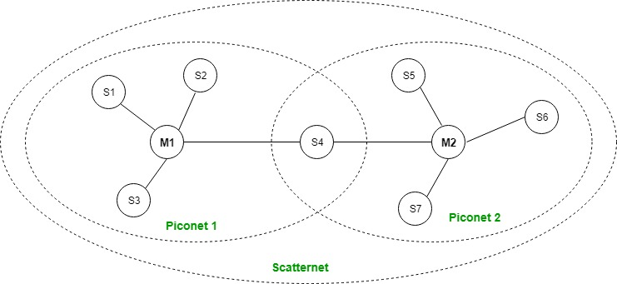

**Piconet:**

Piconet is a type of Bluetooth network that contains one primary node called the master node and seven active secondary nodes called slave nodes. Thus, we can say that there are a total of 8 active nodes which are present at a distance of 10 meters. The communication between the primary and secondary nodes can be one-to-one or one-to-many. Possible communication is only between the master and slave; Slave-slave communication is not possible. It also has 255 parked nodes, these are secondary nodes and cannot take part in communication unless it gets converted to the active state.

**Scatternet:**

It is formed by using various piconets. A slave that is present in one piconet can act as master or we can say primary in another piconet. This kind of node can receive a message from a master in one piconet and deliver the message to its slave in the other piconet where it is acting as a slave. This type of node is referred to as a bridge node. A station cannot be mastered in two piconets.

### Bluetooth protocol stack:

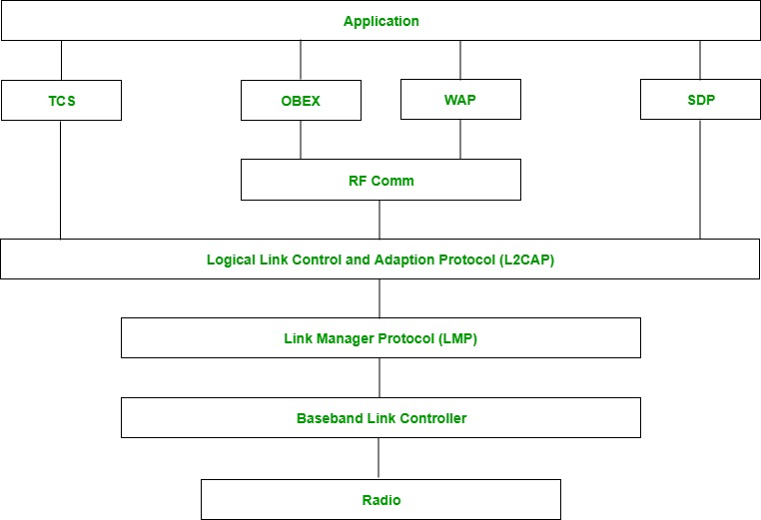

1. **Radio (RF) layer:**

It performs modulation/demodulation of the data into RF signals. It defines the physical characteristics of Bluetooth transceivers. It defines two types of physical links: connection-less and connection-oriented.

1. **Baseband Link layer:**

The baseband is the digital engine of a Bluetooth system and is equivalent to the MAC sublayer in LANs.  It performs the connection establishment within piconet.

1. **Link Manager protocol layer:** It performs the management of the already established links which includes authentication and encryption processes. It is responsible for creating the links, monitoring their health, and terminating them gracefully upon command or failure.
2. **Logical Link Control and Adaptation Protocol layer:** It is also known as the heart of the Bluetooth protocol stack. It allows the communication between upper and lower layers of the Bluetooth protocol stack. It packages the data packets received from upper layers into the form expected by lower layers. It also performs segmentation and multiplexing.
3. **SDP layer:** It is short for Service Discovery Protocol. It allows discovering the services available on another Bluetooth-enabled device.
4. **RF comm layer:** It is short for Radio Frontend Component. It provides a serial interface with WAP and OBEX. It also provides emulation of serial ports over the logical link control and adaptation protocol(L2CAP). The protocol is based on the ETSI standard TS 07.10.
5. **OBEX:** It is short for Object Exchange. It is a communication protocol to exchange objects between 2 devices.
6. **WAP:** It is short for Wireless Access Protocol. It is used for internet access.
7. **TCS:** It is short for Telephony Control Protocol. It provides telephony service. The basic function of this layer is call control (setup & release) and group management for gateway serving multiple devices.
8. **Application layer:** It enables the user to interact with the application.

### Advantage:

* Low cost.
* Easy to use.
* It can also penetrate through walls.
* It creates an Ad-hoc connection immediately without any wires.
* It is used for voice and data transfer.

### Disadvantages:

* It can be hacked and hence, less secure.
* It has a slow data transfer rate: of 3 Mbps.
* It has a small range: 10 meters.
* Bluetooth communication does not support routing.
* The issues of handoffs have not been addressed.

### Applications:

* Used in laptops, and in wireless PCs.
* In printers.
* In wireless headsets.
* Connecting digital cameras wirelessly to a mobile phone.
* Data transfer from one cell phone to another cell phone or computer.
* Medical health care.

**Conclusion-** Thus we understand the implementation of bluetooth file transfer.